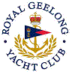 | Royal Geelong Yacht Club Inc.  Est 1859
Trophy Deed of Gift.

Trophy: | Brazier Cup
Presented by: | John Brazier (Music Master at Geelong Grammar School)
Date: | 1969
For: | Invitation Race winner with Geelong Grammar School
Remarks / Revisions | Last known location (5/1996) is GGS

